數值分析

作業三

指導老師: 翁世光 老師

學生: 黃楚祐 學號: 00557043

(A)、(B)

gauss.txt 內容

Exact integration = 17.57162681053757

-----------------------------------------------------------------------------

No. of Gaussian points = 1

No. of interval = 1

Integral= 11.39354693335896

Absolute error= 6.17807987717862

Relative Error= 0.35159407514128

No. of interval = 4

Integral= 22.57209215553448

Absolute error= 5.00046534499691

Relative Error= 0.28457611801761

No. of interval = 16

Integral= 17.33223856763843

Absolute error= 0.23938824289915

Relative Error= 0.01362356744087

No. of interval = 64

Integral= 17.57827318180790

Absolute error= 0.00664637127033

Relative Error= 0.00037824450417

No. of interval = 256

Integral= 17.57204676224064

Absolute error= 0.00041995170307

Relative Error= 0.00002389942079

No. of interval = 1024

Integral= 17.57165306246745

Absolute error= 0.00002625192988

Relative Error= 0.00000149399541

No. of interval = 4096

Integral= 17.57162845129822

Absolute error= 0.00000164076065

Relative Error= 0.00000009337557

No. of interval = 16384

Integral= 17.57162691309565

Absolute error= 0.00000010255807

Relative Error= 0.00000000583657

No. of Gaussian points = 2

No. of interval = 1

Integral= 12.00913322178907

Absolute error= 5.56249358874850

Relative Error= 0.31656110437155

No. of interval = 4

Integral= 17.38690745699310

Absolute error= 0.18471935354447

Relative Error= 0.01051236493560

No. of interval = 16

Integral= 17.51015926691146

Absolute error= 0.06146754362611

Relative Error= 0.00349811342392

No. of interval = 64

Integral= 17.57162581516083

Absolute error= 0.00000099537674

Relative Error= 0.00000005664682

No. of interval = 256

Integral= 17.57162679223433

Absolute error= 0.00000001830324

Relative Error= 0.00000000104164

No. of interval = 1024

Integral= 17.57162681046131

Absolute error= 0.00000000007626

Relative Error= 0.00000000000434

No. of interval = 4096

Integral= 17.57162681053884

Absolute error= 0.00000000000127

Relative Error= 0.00000000000007

No. of interval = 16384

Integral= 17.57162681052679

Absolute error= 0.00000000001078

Relative Error= 0.00000000000061

No. of Gaussian points = 3

No. of interval = 1

Integral= 23.92211683843586

Absolute error= 6.35049002789829

Relative Error= 0.36140592424203

No. of interval = 4

Integral= 18.09979620204846

Absolute error= 0.52816939151088

Relative Error= 0.03005808154281

No. of interval = 16

Integral= 17.56906836545118

Absolute error= 0.00255844508640

Relative Error= 0.00014560092324

No. of interval = 64

Integral= 17.57162651082570

Absolute error= 0.00000029971187

Relative Error= 0.00000001705658

No. of interval = 256

Integral= 17.57162681048396

Absolute error= 0.00000000005361

Relative Error= 0.00000000000305

No. of interval = 1024

Integral= 17.57162681053488

Absolute error= 0.00000000000270

Relative Error= 0.00000000000015

No. of interval = 4096

Integral= 17.57162681053951

Absolute error= 0.00000000000194

Relative Error= 0.00000000000011

No. of interval = 16384

Integral= 17.57162681052672

Absolute error= 0.00000000001085

Relative Error= 0.00000000000062

No. of Gaussian points = 4

No. of interval = 1

Integral= 21.77495485378666

Absolute error= 4.20332804324909

Relative Error= 0.23921109232347

No. of interval = 4

Integral= 17.54425902717954

Absolute error= 0.02736778335803

Relative Error= 0.00155749855452

No. of interval = 16

Integral= 17.57053305063450

Absolute error= 0.00109375990307

Relative Error= 0.00006224579630

No. of interval = 64

Integral= 17.57162681394108

Absolute error= 0.00000000340351

Relative Error= 0.00000000019369

No. of interval = 256

Integral= 17.57162681053520

Absolute error= 0.00000000000238

Relative Error= 0.00000000000014

No. of interval = 1024

Integral= 17.57162681053499

Absolute error= 0.00000000000258

Relative Error= 0.00000000000015

No. of interval = 4096

Integral= 17.57162681053951

Absolute error= 0.00000000000194

Relative Error= 0.00000000000011

No. of interval = 16384

Integral= 17.57162681052672

Absolute error= 0.00000000001085

Relative Error= 0.00000000000062

(C)

Sample point數量相等時，把被積分的範圍切割成更小的範圍，可以使積分精準度增加，但是在sample point = 1時可能出現例外，而且以我把interval number調到16384來說可能太大了，造成的誤差比interval number = 4096來的大，推測是因為做了太多次加法造成的。

(D)

增加sample數量時也能增加積分精準度，只偶爾出現回彈情況，缺點是每增加一個sample point不是要查表，就是要運算，但運算還要再考慮可能產生多餘的誤差。

(E)

我覺得增加interval 可以更明顯的增加精準度。

觀察interval = 1和interval = 4的折線圖，發現sample points = 3時回升，誤差還是很難捉摸；而且增加interval的程式更容易寫，只要調一下迴圈的上限就好，不需要一直寫Gaussian quadrature的points 和 weights。

(F)

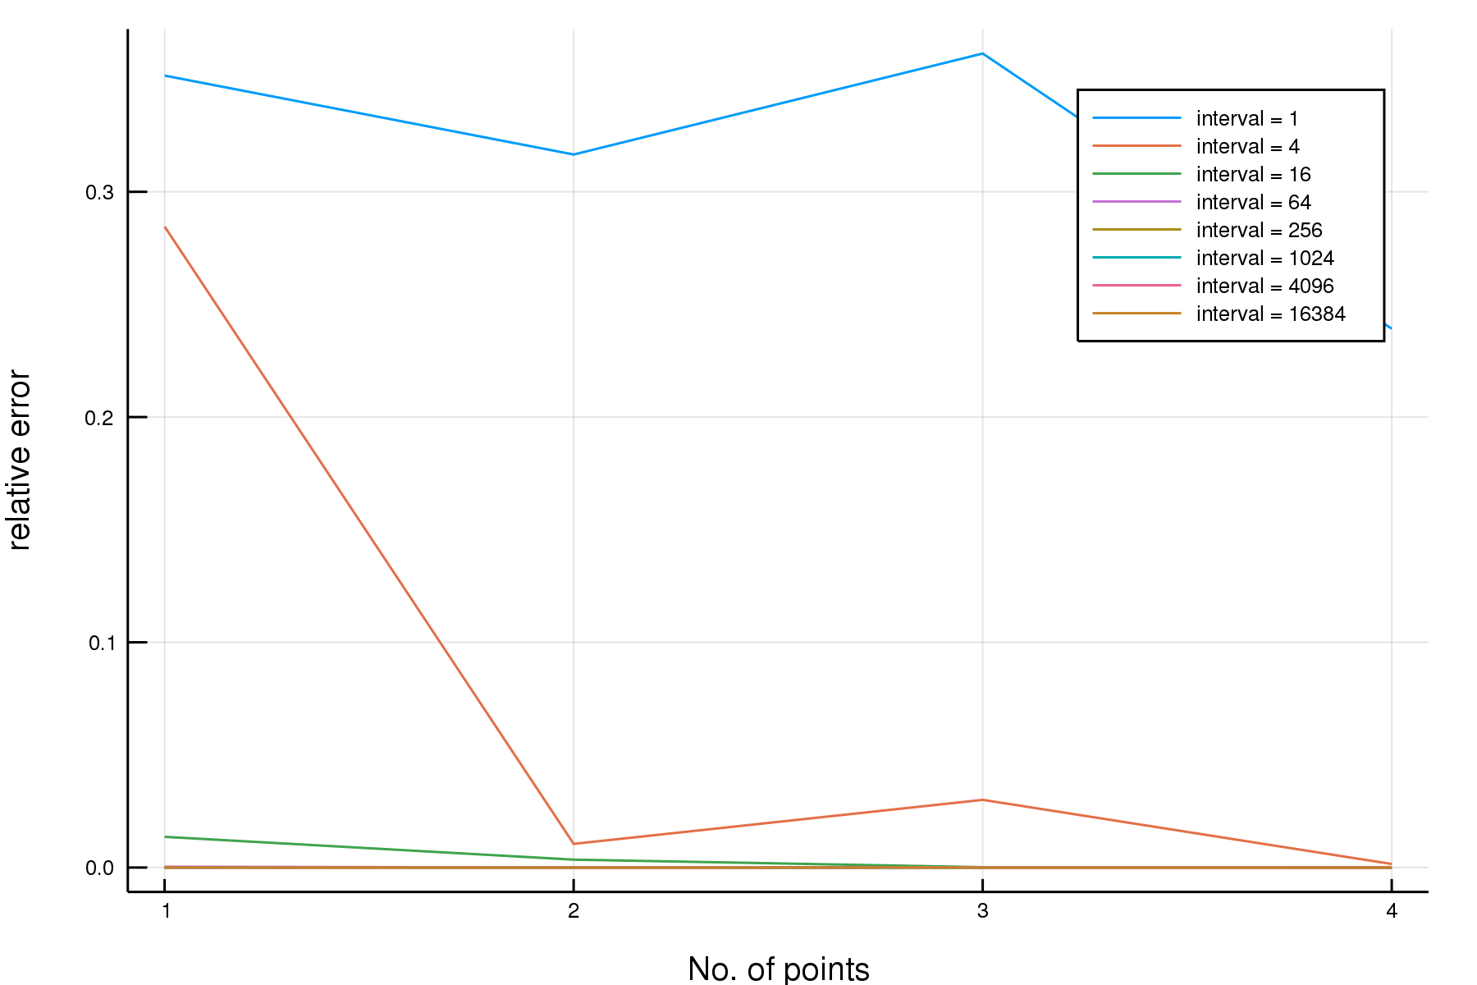(1) 每個interval都列出來

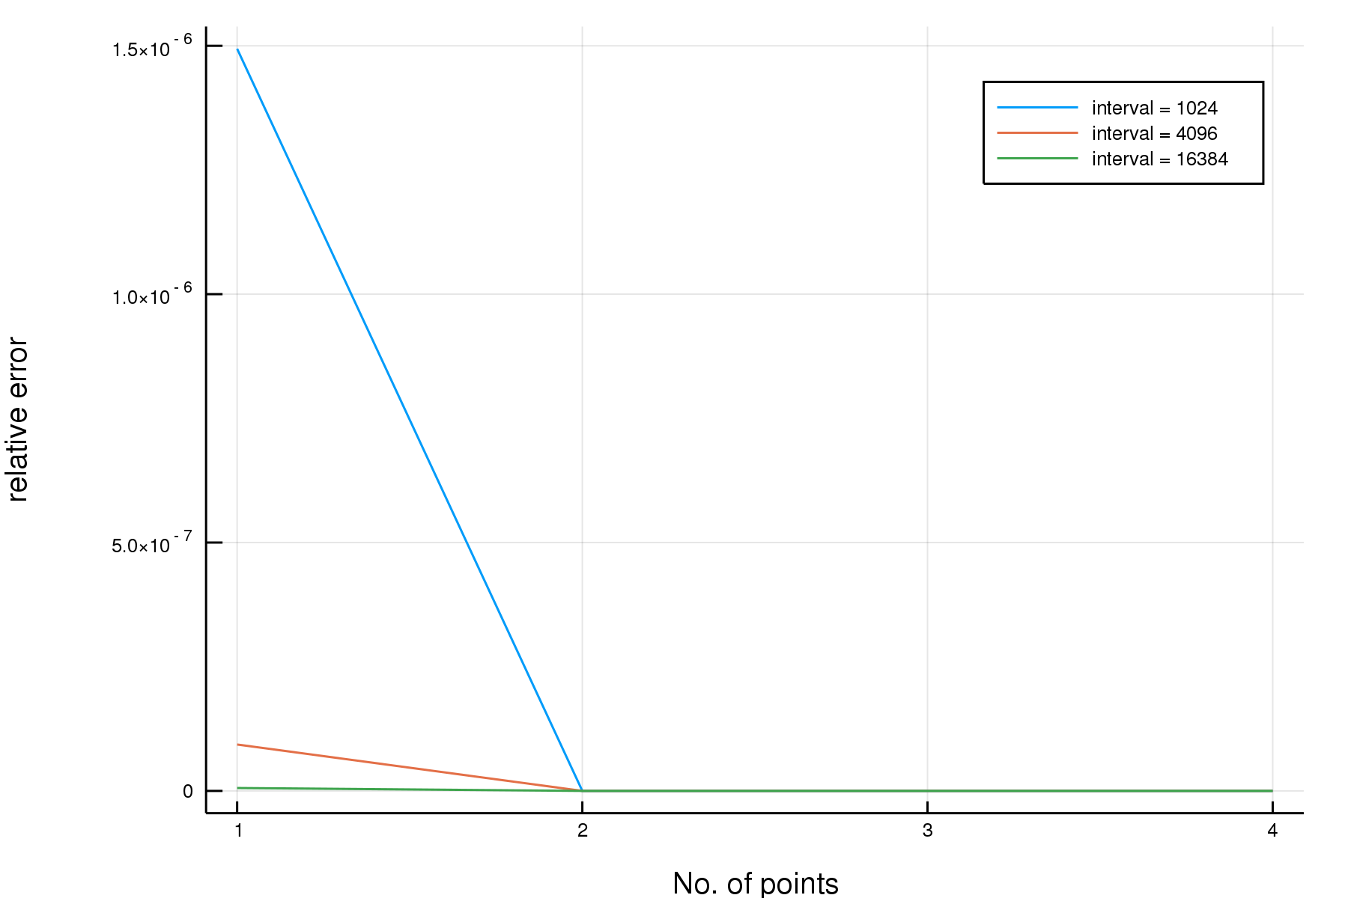(2)只留下大的intervals來比較

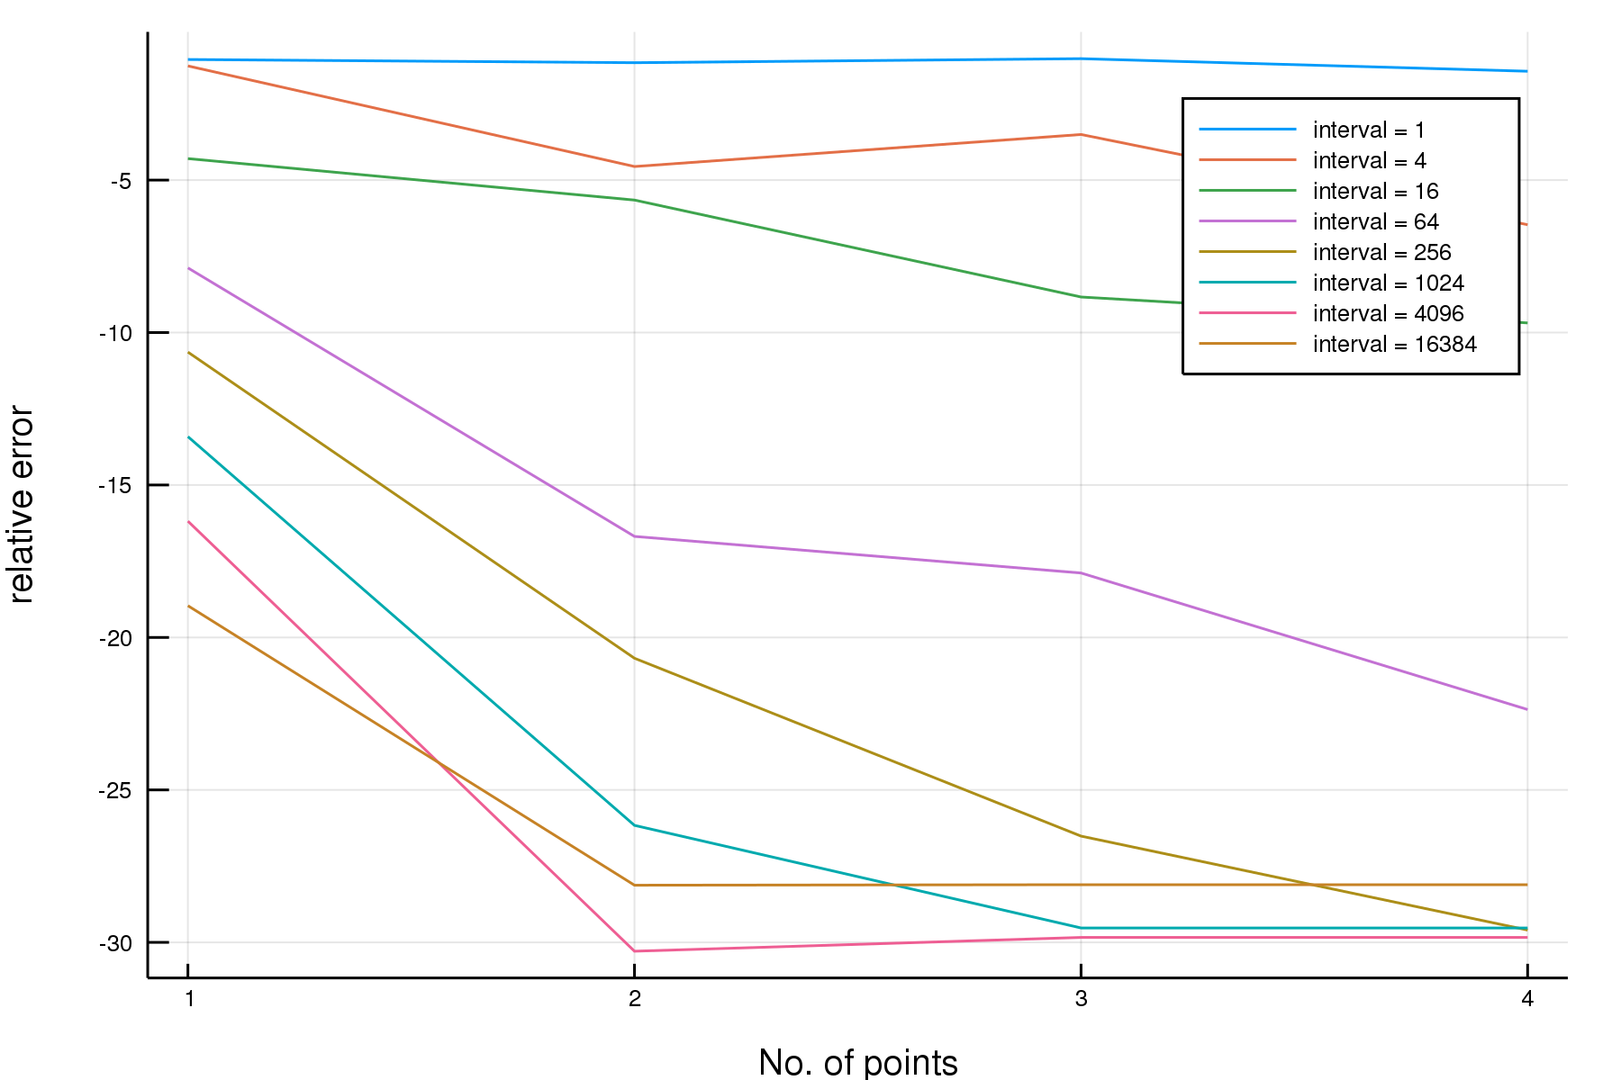(2)取log